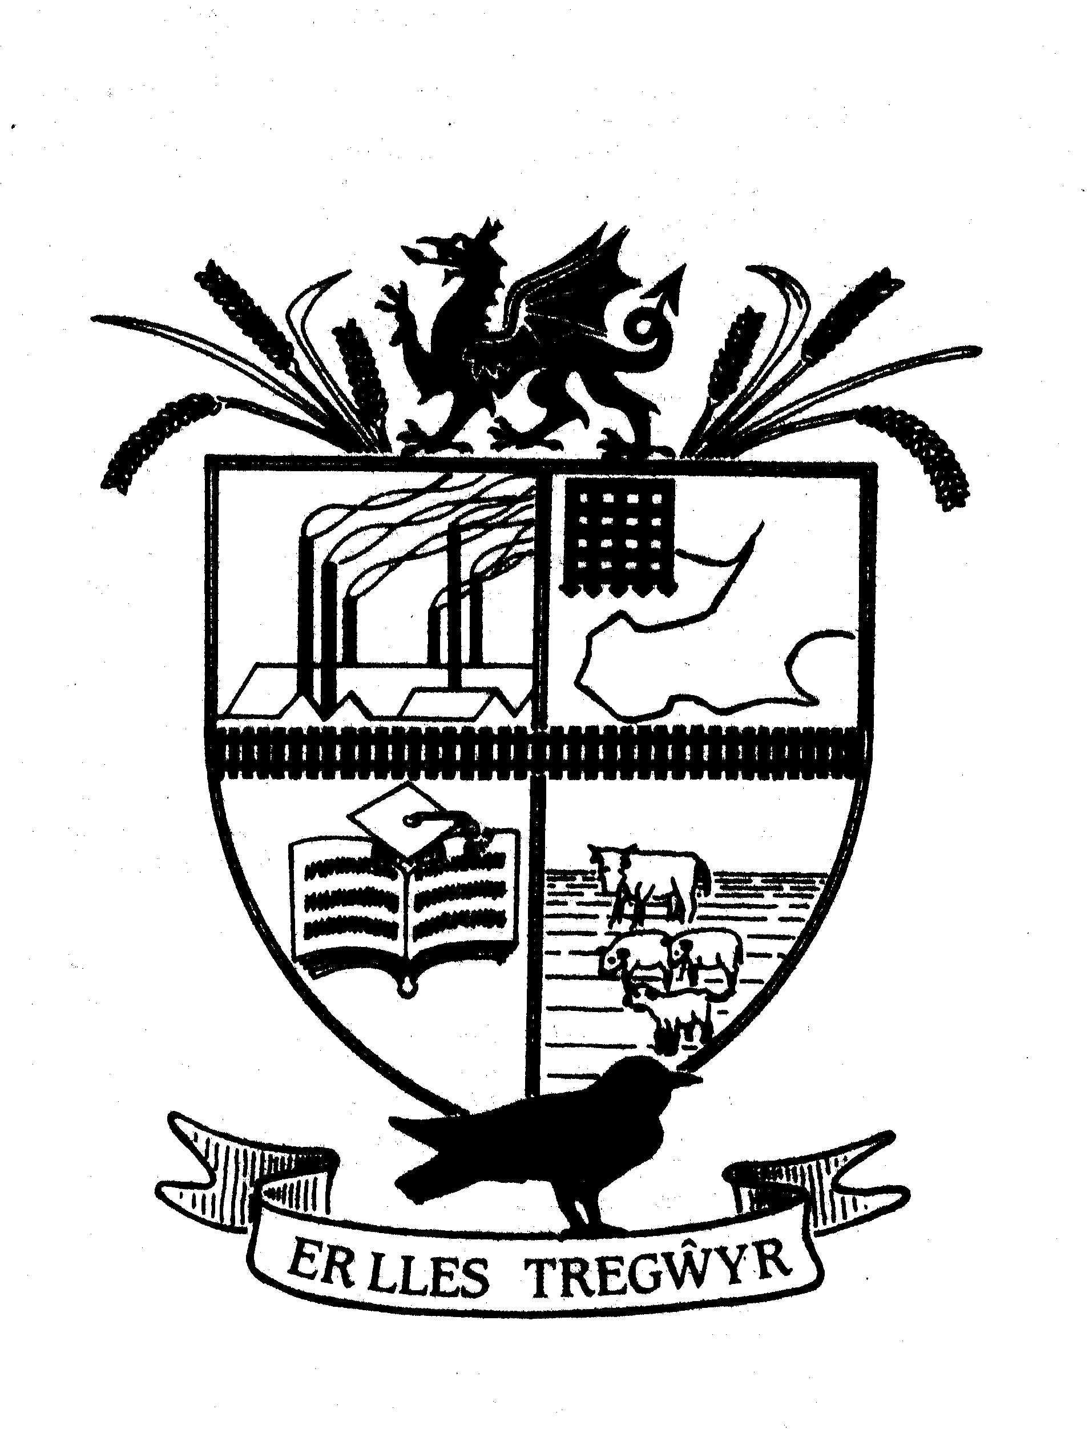

GOWERTON COMMUNITY COUNCIL
Cyngor Cymunedol TREGŴYR
Clerk/RFO to the Council: Allison James,
 Telephone: 0754 5251945 www.gowertoncc.org.uk  E Mail: clerk@gowertoncc.org

__________________________________________________________________________________________________
Meeting of GOWERTON COMMUNITY COUNCIL

Wednesday 8 January 2025

Councillors in attendance : Matthew Palmer (Chairman), Wayne Erasmus, Lynne Carey, Ros Holt

Apologies for absence: Cllrs Susan Jones, Dai Jenkins, Barbara Small, Amanda Guard, Pat Evans, Gareth Evans, Lyneth Howells, June Merrells. Allison James – clerk.

The meeting was inquorate so did not continue.

The agenda will be rolled forward to next month.

Date of next meeting – Wednesday 5 February 2025

Allison James

Allison James
CiLCA

Clerk/RFO to the Council

