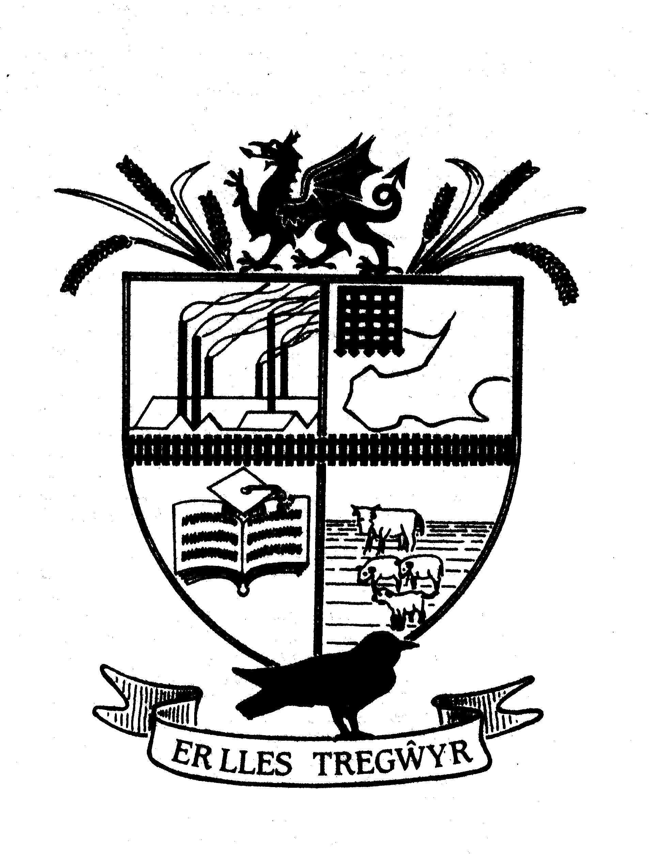

GOWERTON COMMUNITY COUNCIL
Cyngor Cymunedol TREGŴYR
Clerk to the Council: Allison James,
 Telephone: 0754 5251945 www.gowertoncc.org.uk  E Mail: clerk@gowertoncc@org.uk

__________________________________________________________________________________________________
You are duly requested to attend the Annual General Meeting of GOWERTON COMMUNITY COUNCIL which will be held at:

Gowerton Con Club at 7.30pm on Wednesday 1 May 2024

1. Apologies for absence.

2. To receive the report of the retiring Chairperson.

3. To elect the Chairperson for ensuing year.

4. To elect the Vice-Chairperson for ensuing year.

5. Disclosures of Personal Interest from Members

In accordance with the Code of Conduct, adopted by Council on 5th March 2014, Members are requested to identify the Agenda item / Minute No. / Planning Application and subject matter to which the interest relates. Members are reminded that they must withdraw from the meeting if the personal interest is of a type which falls within paragraphs 13 or 14 of the Code, or is such that a member of the public might reasonably conclude that it would significantly affect the Council Member’s ability to act on the merits of the case and in the public interest. If the personal interest is of a type which falls within paragraph 12 of the Code, then whilst the Member is not obliged to withdraw from the meeting, he / she must not vote on the matter although he / she may speak

6. Meetings with: None required.

7. To receive any Public Representations
Members of the public are welcome to speak during Agenda item 4 for up to ten minutes per resident, and are welcome to stay for the duration of the meeting, however members of the public are unable to vote or speak for the remainder of the meeting.

8. To consider the Minutes of the Meeting held in April
- Confirmation
- Matters arising

9. To set the amount of Chairperson’s allowance in pursuit of S34(5) Local Government Act 1972.

10.. To appoint representatives to serve on the following bodies:

a) One Voice Wales Area Committee (2 Members)
b) CCS/Community Council Forum (2 Members)
c) Area 2 Development Control Committee sites visits (1Member
d). Planning Committee (to be implemented only when timescale does not allow before next meeting
within consultation period). (3 Members)
e) Rechabite Community Hall Management Committee (1 Member)
f) Governing Body – Gowerton Primary (1 Member)
g) Link person – Adopt a station scheme (1 Member)

.

10 b To review working practices for 24-25. Review Standing Orders.

11. To receive any announcements from the incoming Chairperson.

12. Public Questions.
i) Questions must relate to items on the agenda.
ii) Questions may be verbal at the Meeting, but if in writing, must be submitted no later than noon on the working day prior to the meeting.
iii) Questions will be dealt with in a 10-minute period.
13. Record of Payments/Finance.

14. Correspondence

15. . Planning Applications & Planning Matters

16. To receive the report of the Ward Member(s).

13. To receive the record of payments/financial matters

14. To receive correspondence.

15. Grounds maintenance – hard standing at the flag pole update.

16 Highways – update on junction by Commerical and Sterry Road.

17. Letter from Gowerton Twinning Association and request for funding to be discussed.

18. Risk Assessment for 2024 to be approved.

19 Set date for next meeting.

Allison James
Clerk to the Council 25 April 2024

